# **KIVIK3-seat sofa, gray**

**Product details $1900**

KIVIK is a generous seating series with a soft, deep seat and comfortable support for your back.Seat cushions with a top layer of memory foam; moulds to the precise contours of your body and regains its shape when you get up.

Read More

**Materials & care**

* **Three-seat sofa frame**
* **Back and seat frame:** Fiberboard, Plywood, Polyurethane foam 20 kg/co., Non-woven polypropylene, Solid wood, Particleboard
* **Armrest frame:** Fiberboard, Plywood, Polyurethane foam 20 kg/co., Polyurethane foam 25 kg/co., Polyester wadding, Solid wood, Particleboard
* **Seat cushion:** Highly resilient polyurethane foam (cold foam) 35 kg/co., Polyurethane memory foam 50 kg/co., Polyester wadding
* **Back cushion:**10% cut polyurethane foam/ 90% polyester fibers, Polyester hollow fibers
* **Lining:** Non-woven polypropylene
* **Cover for 3-seat sofa**
* 100 % polyester
* 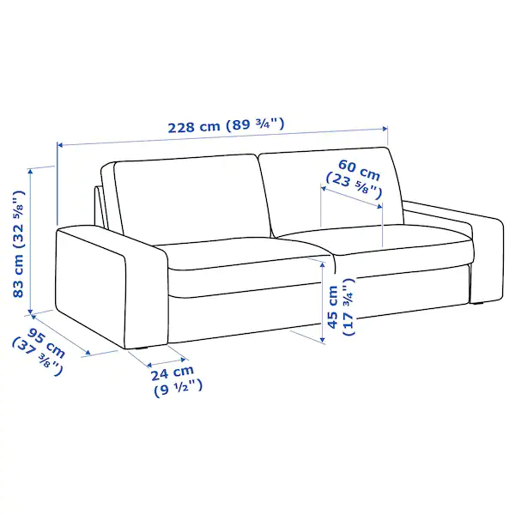**Product size**
* **Width:**
* 228 cm (89 3/4 ")
* **Depth:**
* 95 cm (37 3/8 ")
* **Height:**
* 83 cm (32 5/8 ")
* **Seat width:**
* 180 cm (70 7/8 ")
* **Seat height:**
* 45 cm (17 3/4 ")